Author Information
*Paper Title: Automatic clustering for of MRI images, application on perfusion MRI of brain.
*Paper Authors: P. Chuzel, A. Mansour, J. Ognard, J. Gentric, D. Hamad, N. Betrouni, L. Bressollette
*Conference Name/Date/Place: ICFSP 2016, October 15-17, 2016, Warsaw, Poland.

1st Author Information / Corresponding Author
*Prefix: Mr. |  |  |  | Male□
*First Name: Philippe | *Family Name: Chuzel |  |  | *A clear photo  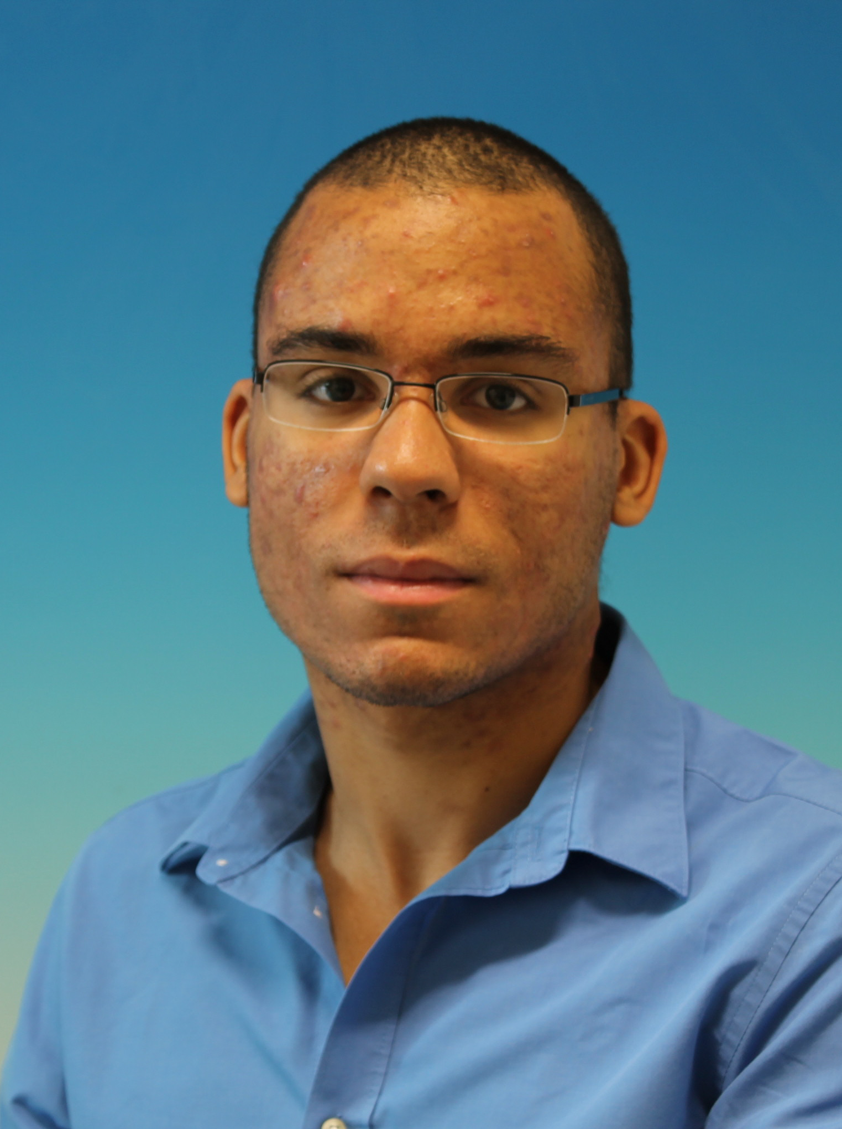
*Affiliation (Organization or University):
ENSTA Bretagne
2 rue Fraçois Verny, Brest
*Country: France |  | *ZIP / Post Code: 29200
*Tel.: 0615549430 |  |  | *E-mail: Philippe.chuzel@ensta-bretagne.org
*Research Interests: Machine learning, Automatic, Robotic, Signal and Image processing.

*Publications: (Please list some representative publications below ) None

2nd Author Information
*Prefix: Prof. |  |  |  | Male□ □
*First Name: Ali | *Family Name: Mansour |  |  | 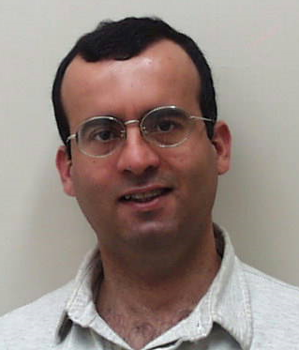
*Affiliation (Organization or University):
LABSTICC ENSTA Bretagne

*Country: France |  | *ZIP / Post Code: 29200
*Tel.: |  |  | E-mail: mansour@ieee.org
*Research Interests:
Blind separation of sources, high-order statistics, signal processing, cognitive radio, robotics and telecommunication.
*Publications: (Please list some representative publications below )
1. A. Mansour and C. Jutten
A direct solution for blind separation of sources
IEEE Trans on SP, Vol 44(3), pages 746 - 748, March 1996
2. A. Mansour
A mutually referenced blind multiuser separation of convolutive mixture algorithm.
Signal Processing , Vol 81(11), pages 2253-2266, November 2001.
3. A. Mansour
"Enhancement of Acoustic Tomography using Spatial and Frequency Diversities"
EURASIP Journal on Advances in Signal Processing, Volume:doi:10.1186/1687-6180-2012-225 , Issue: On Line, 24 Oct 2012. The electronic version of this article is the complete one and can be found online at: http://asp.eurasipjournals.com/content/2012/1/225
A. Mansour, R. Mesleh, R. and H. Aggoune,
"Blind estimation of statistical properties of non-stationary random variables"
EURASIP Journal on Advances in Signal Processing, Volume:doi:10.1186/1687-6180-2014-21 , Issue: On Line, 20 February 2014. The electronic version of this article is the complete one and can be found online at: http://asp.eurasipjournals.com/content/2014/1/21
3rd Author Information
*Prefix: (Prof., Assoc. Prof., Asst Prof., Dr., Mr. Ms. etc.)  DR (PHD) |  |  |  | Male
*First Name:Jean-Christophe | *Family Name: Gentric |  |  | *A clear photo  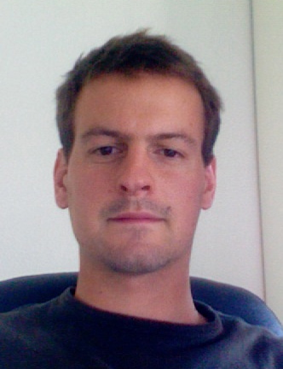
*Affiliation (Organization or University):
1 Brest university Hospital
2 GETBO Groupe d’étude de la Thrombose en Bretagne Occidentale
*Country:FRA |  | *ZIP / Post Code:29200
*Tel.:0298347479 |  |  | *E-mail:jean-christophe.gentric@chu-brest.fr
*Research Interests:
Aneurysm, Neuroimaging, clinical Trial

*Publications: (Please list some representative publications below )
http://www.ncbi.nlm.nih.gov/pubmed/?term=gentric+jc

4th Author Information
*Prefix: Prof. |  |  |  | Male□ □
*First Name: Denis | *Family Name: Hamad |  |  | 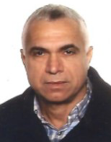
*Affiliation (Organization or University):
University of Littoral Côte d’Opale - LISIC
50 rue F. Buisson Calais Cedex 719
*Country: France |  | *ZIP / Post Code: 62228
*Tel.: +33(0)321465660 |  |  | *E-mail:denis.hamad@lisic.univ-littoral.fr
*Research Interests:
Feature selection, pattern recognition, machine Learning,

*Publications: (Please list some representative publications below )
1. Porebski A., Vandenbroucke N. Macaire L. and Hamad D. A new benchmark
image test suite for evaluating color texture classification schemes. Multimedia
Tools and Applications Journal, Volume 70, Issue 1, pp. 543-556, 2014
2. Rousseeuw K., Poisson-Caillault E., Lefebvre A., and Hamad D. Hybrid Hidden
Markov Model for Marine Environment Monitoring. IEEE Journal of Selected Topics
in Applied Earth Observations and Remote Sensing. Vol. 8, Issue 1, pp. 204-213,
2014.
3. Kalakech M., Biela Ph., Hamad D. and Macaire L. Constraint score evaluation for
spectral feature selection. Neural Processing Letters, vol. 38, issue 2, pp. 155-175,
Oct. 2013.
4. Wacquet G., Poisson Caillault E., Hamad D. and Hébert P.A., Constrained
Spectral Embedding for K-Way Data Clustering. Pattern Recognition Letters,
Volume 34, Issue 9, pp. 1009-1017, 2013.
5. Kalakech M., Biela Ph., Macaire L., Hamad D. Constraint scores for semisupervised
feature selection: A comparative study. Pattern Recognition Letters
vol. 32, pp. 656-665, April 2011.

5th Author Information
*Prefix: (Prof., Assoc. Prof., Asst Prof., Dr., Mr. Ms. etc.) Prof. |  |  |  | Male■ Female□
*First Name: Luc | *Family Name: Bressollette |  |  | 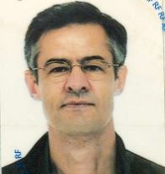
*Affiliation (Organization or University):
INSERN CIC 1412 & GETBO EA3878
*Country: France |  | *ZIP / Post Code: 29200
*Tel.: 0298347545 |  |  | *E-mail: luc.bressollette@chu-brest.fr
*Research Interests:
Vascular medicine, thrombus datation, 3D ultrasonography

*Publications: (Please list some representative publications below )
Can ARFI elastometry of the salivary glands contribute to the diagnosis of Sjögren's syndrome?
Samier-Guérin A, Saraux A, Gestin S, Cornec D, Marhadour T, Devauchelle-Pensec V, Bressollette L, Nonent M, Jousse-Joulin S. Bressollette L
Joint Bone Spine. 2016 May;83(3):301-6. doi: 10.1016/j.jbspin.2015.11.002. Epub 2015 Dec 8.

Six Months vs Extended Oral Anticoagulation After a First Episode of Pulmonary Embolism: The PADIS-PE Randomized Clinical Trial.
Couturaud F, Sanchez O, Pernod G, Mismetti P, Jego P, Duhamel E, Provost K, dit Sollier CB, Presles E, Castellant P, Parent F, Salaun PY, Bressollette L, Nonent M, Lorillon P, Girard P, Lacut K, Guégan M, Bosson JL, Laporte S, Leroyer C, Décousus H, Meyer G, Mottier D; PADIS-PE Investigators.
JAMA. 2015 Jul 7;314(1):31-40. doi: 10.1001/jama.2015.7046.

Brief Report: Ultrasonographic Assessment of Salivary Gland Response to Rituximab in Primary Sjögren's Syndrome.
Jousse-Joulin S, Devauchelle-Pensec V, Cornec D, Marhadour T, Bressollette L, Gestin S, Pers JO, Nowak E, Saraux A.
Arthritis Rheumatol. 2015 Jun;67(6):1623-8. doi: 10.1002/art.39088.
.
Normal sonoanatomy of the paediatric entheses including echostructure and vascularisation changes during growth.
Jousse-Joulin S, Cangemi C, Gerard S, Gestin S, Bressollette L, de Parscau L, Devauchelle-Pensec V, Saraux A.
Eur Radiol. 2015 Jul;25(7):2143-52. doi: 10.1007/s00330-014-3586-y. Epub 2015 Feb 8.

Validation of the LEFt score, a newly proposed diagnostic tool for deep vein thrombosis in pregnant women.
Le Moigne E, Genty C, Meunier J, Arnoult AC, Righini M, Bressollette L, Bosson JL, Le Gal G; OPTIMEV Investigators.
Thromb Res. 2014 Sep;134(3):664-7. doi: 10.1016/j.thromres.2014.07.009. Epub 2014 Jul 17.

This submission is reported original, previously unpublished research results, experimental or theoretical. And this submission is not being under consideration for publication elsewhere.

I’m on behalf of all co-authors commit that the above information is true.
Signature:

